NATIONAL UNIVERSITY OF SCIENCES AND TECHNLOGY

(DEPARTMENT OF MECHANICAL ENGINEERING)

FUNDAMENTALS OF PROGRAMMING

NAME: Syed Ali Naqi

SUBMITTED ON: 20-10-2023

CMS ID: 466889

**TASK 1:**

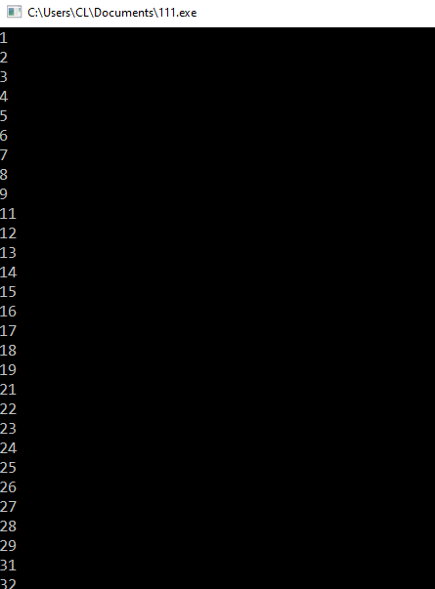#include <iostream>

using namespace std;

int main() {

for(int i=1; i<=150; i++){

if(i % 10 == 0) {

continue;

}

cout<<i<<" "<<endl;

}

return 0;

}

**TASK 2:**

#include <iostream>

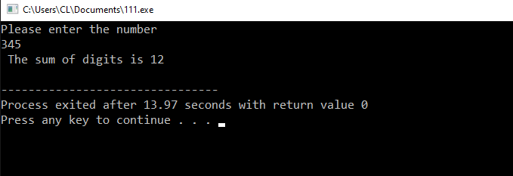using namespace std;

int main() {

int num, digit, sum=0;

cout<<"Please enter the number"<<endl;

cin>>num;

while( num> 0){

digit= num % 10;

sum += digit;

num /= 10;

}

cout<<" The sum of digits is"<<" "<<sum<<endl;

return 0;

}

**TASK 3:**

#include <iostream>

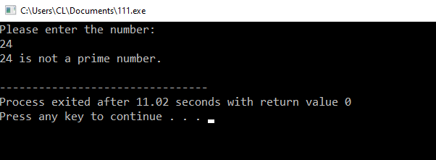using namespace std;

bool isPrime( int number){

if (number <=1 ){

return false;

}

for (int i= 2; i* i<=number ; i++){

if (number % i==0){

return false;

}

}

return true;

}

int main(){

int number;

cout<<"Please enter the number:"<<endl;

cin>> number;

if( isPrime(number)){

cout<< number<< "is a prime number."<<endl;

} else {

cout << number<<" "<<"is not a prime number."<<endl;

}

return 0;

}